Episode 202: Forces in equilibrium

In this episode, students will learn about the conditions for static equilibrium (excluding moments of forces).

Summary
Demonstration and discussion: The washing line. (10 minutes)
Student experiment: Forces in different directions. (15 minutes)
Student experiment: Forces in equilibrium. (20 minutes)
Worked example and Demonstration: (15 minutes)
Student activity: An estimation. (15 minutes)
Student questions: Two problems. (30 minutes)

Demonstration + Discussion:
The washing line

Take 5 m of good strong string. Ask two pupils to take either end and pull the string taut. Hang a 1kg mass (10 N force) from the middle of the string. The pupils will find it very difficult (impossible, in fact) to keep the string horizontal.

Drawing a vector triangle of the forces will show why the pupils have had such problems.
Student should understand that the sum of the vertical components of the tensions in the string is equal in magnitude (and of opposite sign) to the weight hanging from the middle.
Similarly, the horizontal components of the tension in the strings are also equal and opposite. Why must this be the case? (Otherwise the string would start to move horizontally.)
You could finish the discussion with a statement of the principles of equilibrium. For an object to be in equilibrium the forces on it must be balanced; we can check this by resolving in two perpendicular directions. This will give the next activity a sense of a corroborative experiment.

Student experiment:
Forces in different directions
This activity builds upon the opening discussion. Encourage the students to discuss the questions posed on the worksheet – if they don’t it just becomes a tug-of-war. Gather the class together at the end of the activity to compare ideas and clear up misconceptions.

TAP 202-1: Forces in different directions

Student experiment:
Forces in equilibrium
This activity focuses on vector triangles. The fact that the triangles the students draw won’t quite close can be a springboard for discussion but you should not allow it to dominate the thinking of the less able students – the purpose of the demonstration is to give practice in using a graphical technique to consider forces in equilibrium, and show that it works!

TAP 202-2: Forces in equilibrium

Worked example + Demonstration
You can use this worked example in conjunction with the apparatus described in the question.
This example considers forces in equilibrium in a ‘new’ situation – a trolley on a slope.

N
F
W
θ
W
F
R

Having completed sections a – e, good students might like to resolve parallel to the runway to show that F cos θ = W sin θ 
TAP 202-3: Trolley on a slope

Student activity:
An estimation
Students can apply what they have learned to the equilibrium of a pylon supporting power lines. You may find it useful to give a lead in to the question and draw the diagram of the situation out for them. A picture can be used if you do not have pylons in the locality.
You may want to model the situation in class. In this case, a length of chain between two stools will show the students the effect and allow you to rehearse the calculations with them.

TAP 202-4: Forces acting on a power line

Student questions:
Two problems
The first question should be a straightforward confidence-booster as it mirrors the algebraic analysis covered in the episode.
The second question is another scale drawing exercise. Mathematically fluent students should be encouraged to analyse the problem trigonometrically using the sine rule.

TAP 202-5: Questions on forces and equilibrium
TAP 202- 1: Forces in different directions

Use the arrangement shown below to explore the effect of pulling ropes in different directions but still trying to maintain equilibrium. Try the things suggested below, and think about and discuss the questions as you go along.

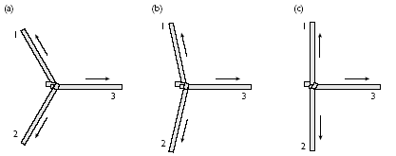

Initially arrange the ropes horizontally so that they make equal angles of 120° with each other as in Figure (a) above. The force in a rope that is being pulled is called the tension.
What does symmetry suggest about the tension in each rope?
Since you aren’t measuring any forces here you cannot test your answer directly, but you might try the following argument: keeping the angles the same, rotate in your threesome around the knot through 120° so that one rope has replaced its neighbour.
Do you feel any difference in the rope you are holding?
(You might think this reasoning is a bit of a cheat, but in fact arguments based on symmetry can be extremely powerful tools in making theoretical predictions in physics.)
What do you have to do to the tensions to produce an arrangement like Figure (b)?
How do the tensions in ropes 1 and 2 compare with that in 3?
Is it ever possible to produce the arrangement in Figure (c) by pulling on the ropes?

Practical advice
This section uses a series of activities to develop ideas about combining and resolving vectors.
Students with a strong mathematical background and aptitude could be asked to work through this section independently of the teacher, in pairs or small groups– a lot of good learning can take place like this. In order to identify any problems, students can be asked to discuss with you their results from the activities and their answers to the questions. On the other hand, students whose maths background is weak will probably need a lot of support and should not be left to struggle.

This is a qualitative look at the directional aspect of forces, starting from an intuitive symmetrical arrangement. We recommend using climbing ropes and doing the activity in a large space. It is not essential to use climbing ropes but their use is strongly recommended.
Alternatively, use bench pulleys and slotted masses as shown below

Pulley
Slotted masses

Technicians Note:
Apparatus
- 2 lengths of rope (approx. 4 m and 2 m long) with the short length firmly knotted to the middle of the longer
Optional
- three bench pulleys
- slotted masses 3 × 10 × 0.1 kg

A rich source of climbing rope data, including testing procedures, is the BEAL catalogue. The UK distributor is:
LYON Equipment
Dent
Sedbergh
Cumbria LA10 5QL

External references
This activity is taken from Salters Horners Advanced Physics, AS, Section Higher, Faster, Stronger, HFS Activity 11
TAP 202- 2: Forces in equilibrium

Use the apparatus shown in Figure 1 to investigate whether force vectors combine like displacement vectors.

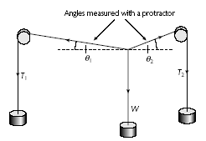
Above: Figure 1

Making measurements
Mark on the graph paper behind the knot the direction of each string. You may find it possible to use a protractor behind the string, or to project an image of a clear protractor onto the board, in order to find the angles θ₁ and θ₂ which each string makes with the vertical.
The tensions T₁ and T₂ are the weights hanging from the pulleys (assuming friction at the pulleys is negligible): if each loose mass is 0.1 kg you may take its weight as 1 N, or alternatively you can work in arbitrary units of the weight of one mass (if all the masses are the same the actual weight in newtons is irrelevant).

Keep W fixed and record in a table its value and the values of T₁, T₂, θ₁ and θ₂ for about four different arrangements. You may need to do some trialling first to establish a convenient value of W.

Analysing the results
For each equilibrium arrangement, construct a vector addition diagram and see if it is closed – do we end up back where we started? The critical step is to choose a scale so that each force is represented by a line of length proportional to its magnitude, e.g. 2 cm to 1 N.

Share the drawing tasks amongst your group and compare diagrams.

A typical set of forces is shown in figure 2a. Figure 2b shows the corresponding vector diagram: notice that it is quite separate from the space diagram in figure 2a. It is obvious that the diagram in figure 2b is nearly closed – i.e. a triangle – but there is a small residual vector OP apparently showing a resultant.

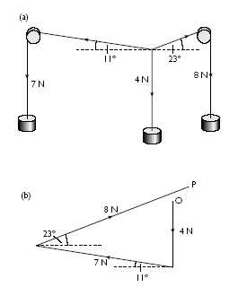
Above: Figure 2

Can you see any assumption you are making in measuring the tensions which might tend to prevent the diagram from closing?
What could you do to the apparatus which would have the effect of reducing the length OP?

Practical advice
A force board is not strictly necessary (clamped pulleys could be used) but even an improvised one out of peg board makes the whole arrangement much less likely to collapse in a cascade of slotted masses. The most convenient starting arrangement is the symmetrical 120° one, and then move away from that in controlled steps. In Figure 2(b) the residual vector OP can be attributed to experimental uncertainties in the measurements of angle, and regarded as some measure of the effect of friction at the pulleys.

Technicians Note
Apparatus
- force board with 2 pulleys (or equivalent robustly
- clamped arrangement)
- three 10 × 0.1 kg hanging masses*
- fine string
- graph paper
- protractor
* If using a small board (30 × 30 cm), use 0.01 kg slotted masses.

External references
This activity is taken from Salters Horners Advanced Physics, AS, Section Higher, Faster, Stronger, HFS, Activity 13

TAP 202- 3: A trolley on a slope

The diagram shows a frictionless trolley on a slope. The trolley is held stationary by the horizontal force F.

W
N
F
θ

Explain why the horizontal component of the normal reaction must be equal in magnitude to the force F if the trolley is in equilibrium. Explain why this is also the case when the trolley is moving down the slope at constant velocity.

Find the horizontal component of N.

Explain why the vertical component of the normal reaction must be equal in magnitude to the weight W if the trolley is in equilibrium.

Find the vertical component of N.

(e) Combine your answers to (b) and (d) to show that F = W tan θ
TAP 202- 4: Forces acting on a power line

Study (from a safe distance!) an overhead power cable and estimate the force acting on the pylon.
With careful use of a pair of rulers at right angles, and a transparent protractor to find roughly the angle the cable makes with the horizontal where it joins the pylon, make a scale drawing of the cable as accurately as you can.
Consider the equilibrium of one half of it only, from the centre to the pylon. Mark on your diagram the three forces holding it in equilibrium (in deciding where the weight acts, you may ignore the curvature of the cable).
Now extend the lines of action of the three forces to demonstrate how they must meet at one point. In finding the direction of the tension at the pylon, can you see how you didn’t in fact need to measure the angle?
Draw a triangle of forces for the equilibrium of the half of the cable. You will need a lot of ‘sideways space’ on the paper – sketch it roughly first to see why.
If the cable has a mass per unit length of 1.7 kg m^{–1}, estimate the force that the cable is exerting on the pylon. (Take g = 9.8 N kg^{–1}.)

Practical advice
The aim of this activity is to give students additional experience with force vector triangles and to encourage them to exercise a bit of ingenuity in obtaining and analysing their measurements. You could use a photograph instead of having students go out looking at power cables.
Typical values are shown in diagram (a).
(The exact values for 400 kV cables are 265.8 m span and 12.27 m sag.)

Answers and worked solutions
The three forces in equilibrium are shown in diagram (b), meeting at point X. The angle θ is exaggerated – it is really between 7° and 8°.

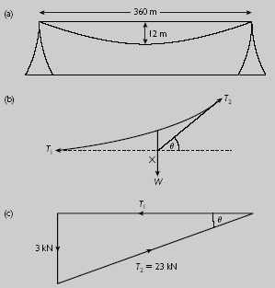

The total weight of the half-cable is 1.7 kg m⁻¹× 180 m × 9.8 N kg⁻¹ = 2998.8 N = 3 kN. The triangle of forces is shown in diagram (c).
The force T2 (approximately 23 kN) in the direction shown is the force of the pylon on the cable: the force of the cable on the pylon is in the opposite direction.
Brief technical details of the cable might be of interest. The cable described is one of a group of four which are linked by a sequence of cross-braces which together make up one conductor. There are six such conductors making a total of 24 cables, together with a lighter earth cable joining the tops of the pylons.
Each cable consists of 54 aluminium and 7 steel stands, each of diameter 3.17 mm.

External references
This activity is taken from Salters Horners Advanced Physics, AS, Section Higher, Faster, Stronger, HFS Activity 15
TAP 202- 5: questions on forces and equilibrium

1 The weight of the trolley in the diagram is 3.4 N. The trolley is not moving.
3.4 N
N
F
25^{ο}
Calculate
(a) the normal reaction, N, and
(b) the horizontal force, F.

2 The diagram below shows a circus performer in a high-wire act.

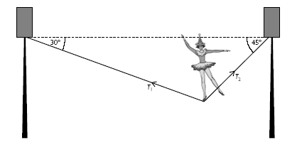

(a) The total mass of the performer plus props is 76.5 kg. Using a scale of 1 cm to 100 N, draw a vector triangle to show the forces acting on the performer.
(b) Use your diagram to find the tensions T₁ and T₂ in the cable.
(c) A member of the audience is worried that the cable might break, and thinks that this would be less likely to happen if the cable were shorter so that it did not sag so much.
Explain, with the aid of a diagram, whether this would really reduce the tension in the cable.

Answers and worked solutions
1
(a) N = 3.4 / cos 25° = 3.75 N
(b) F = N cos 65° = 1.59 N

2 (a) W = mg = 76.5 kg × 9.81 N kg⁻¹ = 750 N

Scale diagram:

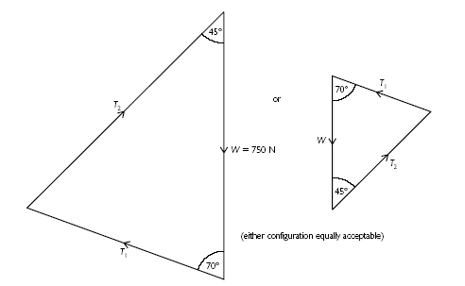

b) T1 = 590 N, T2 = 780 N
(Calculated values are T1 = 585 N, T2 = 778 N. Allow ± 15 N measured from diagram, i.e. ± 1.5 mm.)
(c) The ‘vertical’ side of the triangle of forces must still be 750 N but the other two sides
will now be longer than before so tension will be increased not reduced

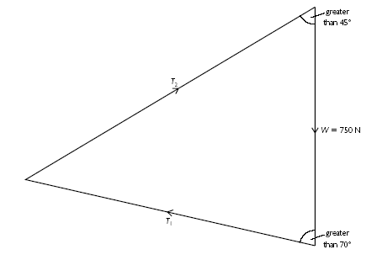

External references
Question 2: This activity is taken from Salters Horners Advanced Physics, AS, Section Higher, Faster, Stronger, HFS Additional sheets 12 and 13

